**Appendix A**

**A1. Component Layout**

**Subscriber Circuit**

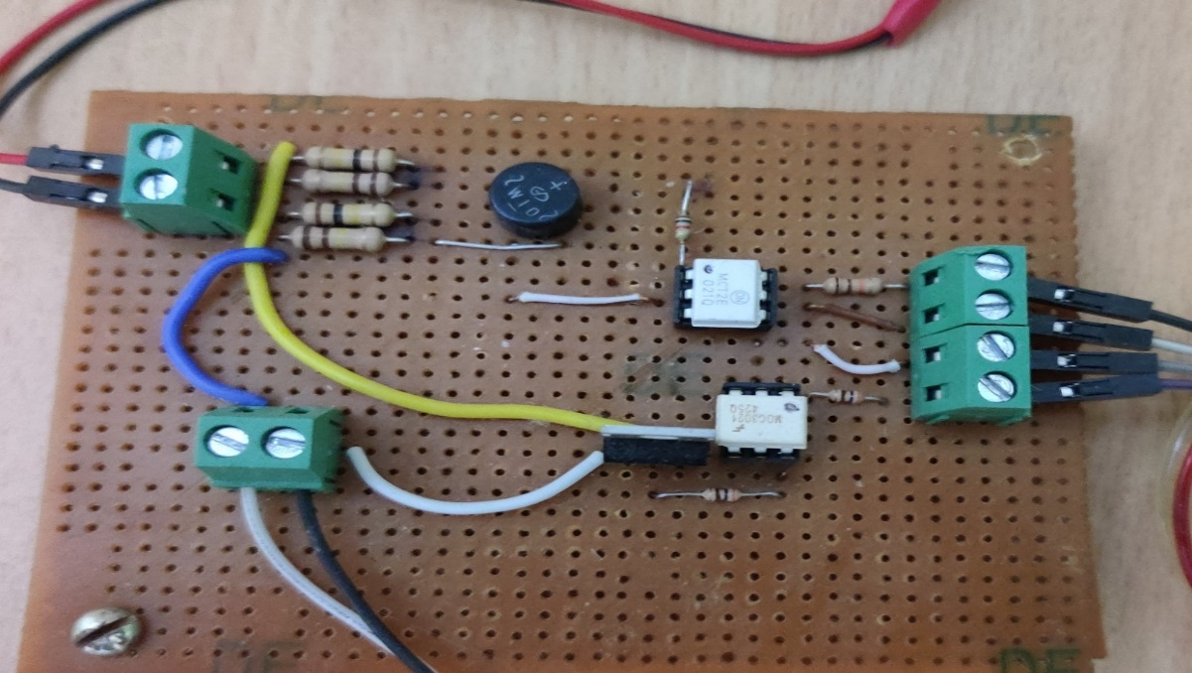

**Publisher Circuit**

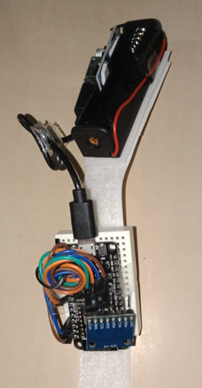

**A2. Circuit Diagram**

**Subscriber Circuit**

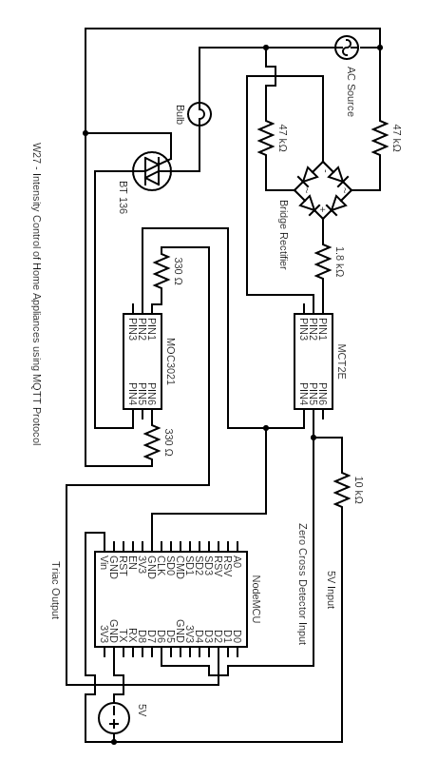

**Publisher Circuit**

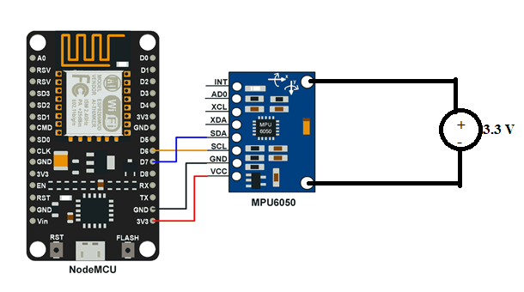

**A3. Component List**

|  |  |  |
| --- | --- | --- |
| **Sl no.** | **Name of the component** | **Quantity** |
| **1.** | Node MCU [ESP8266] | 2 |
| **2.** | Accelerometer | 1 |
| **3.** | Battery 3.3V | 1 |
| **4.** | MOC3021 Octocoupler | 1 |
| **5.** | MCT 2E Octocoupler | 1 |
| **6.** | BT 136 Triac | 1 |
| **7.** | Bridge Rectifier | 1 |
| **8.** | Resistor - 47K ohm | 2 |
| **9.** | Resistor -1.8K ohm | 1 |
| **10.** | Resistor - 330 ohm | 2 |
| **11.** | Resistor - 10K ohm | 1 |
| **12.** | Bulb | 1 |
| **13.** | Fan | 1 |
| **14.** | Connecting Wires | Few |

**A4. Main Components Data Sheets**

**A4.1 Node MCU**

**ESP8266 Pin Configuration**

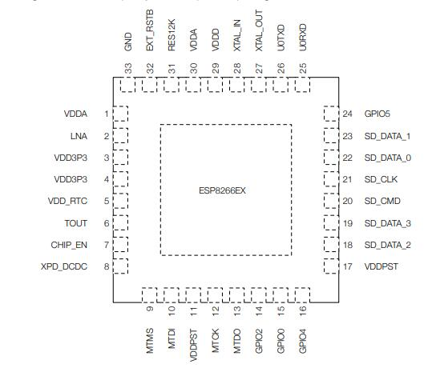

**Pin Functions**

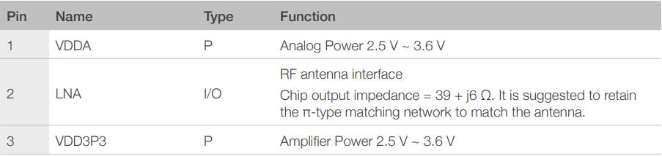

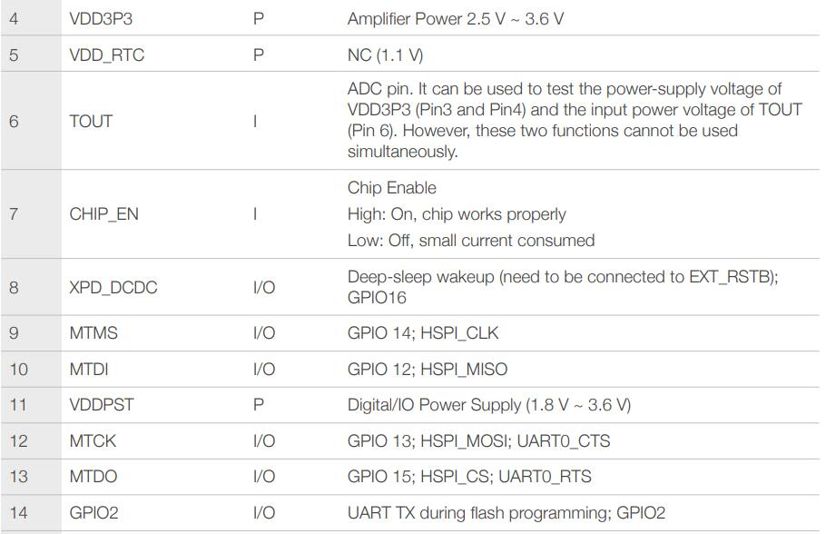

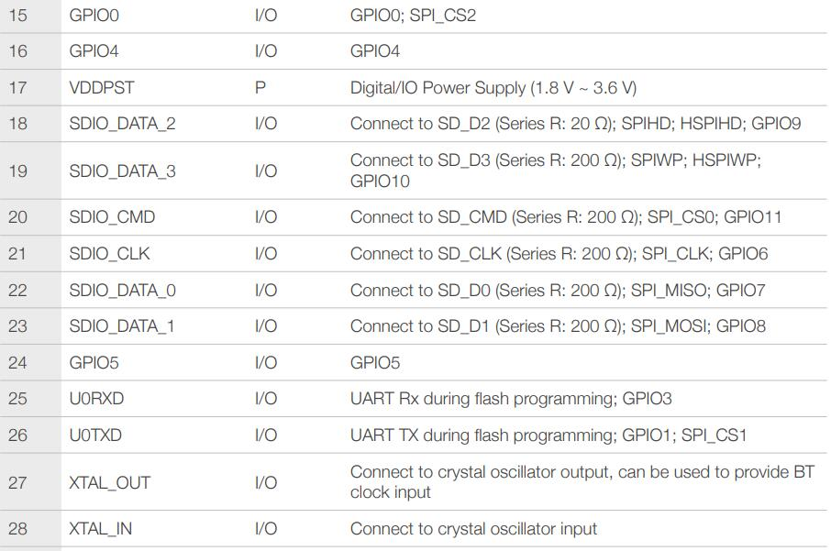



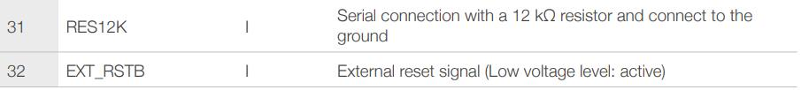

**Functional Block Diagram**

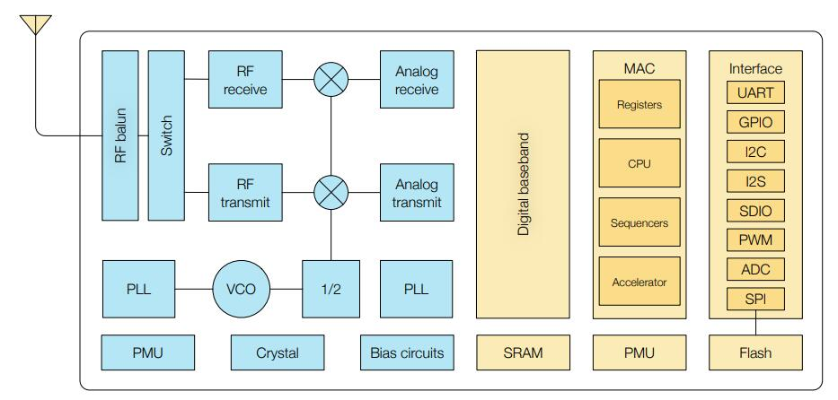

ESP8266 Functional Block Diagram

**Features**

* 802.11 b/g/n support
* 802.11 n support (2.4 GHz), up to 72.2 Mbps
* Defragmentation
* 2 x virtual Wi-Fi interface
* Automatic beacon monitoring (hardware TSF)
* Support Infrastructure BSS Station mode/SoftAP mode/Promiscuous mode

**Specifications**

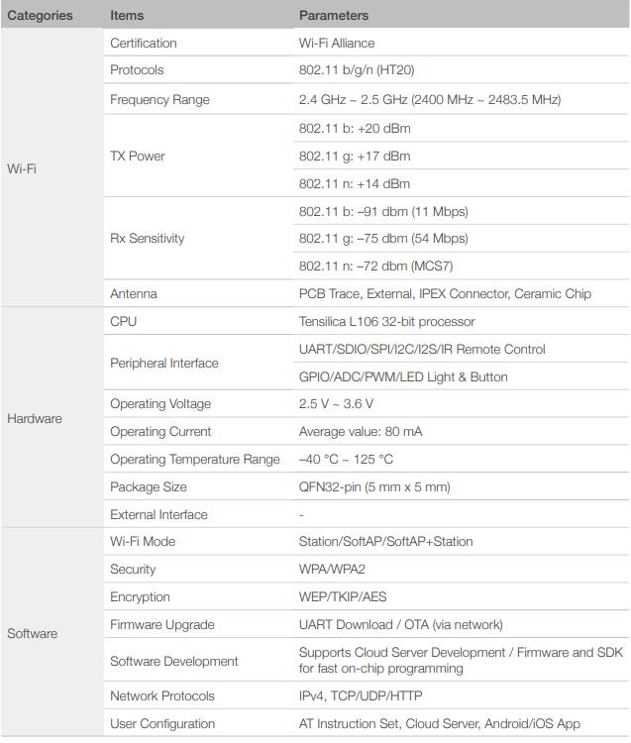

**A4.2 Accelerometer**

**Pin Configuration**

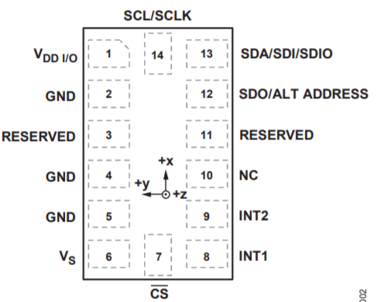

**Pin Functions**

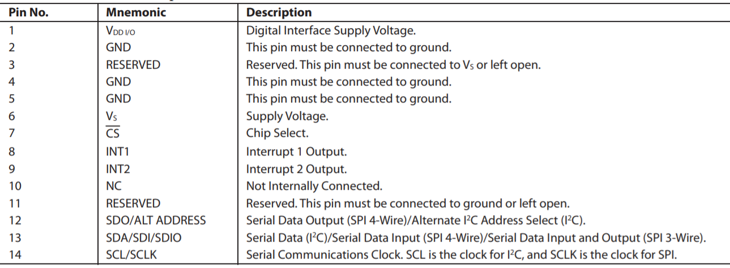

**Functional Block Diagram**

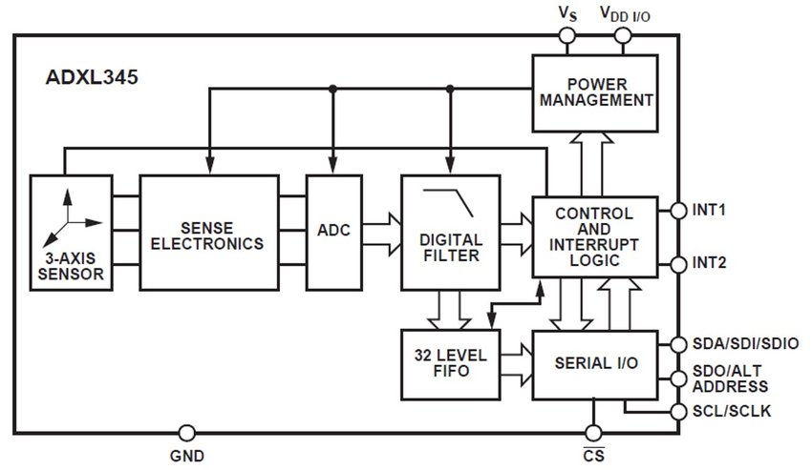

**Features**

1. Small, thin, ultralow power
2. 3-axis accelerometer with high resolution (13-bit) measurement at up to ±16 g.
3. Digital output data is formatted as 16-bit twos complement and is acces- sible through either a SPI (3- or 4-wire) or I2C digital interface.

**Specifications**

